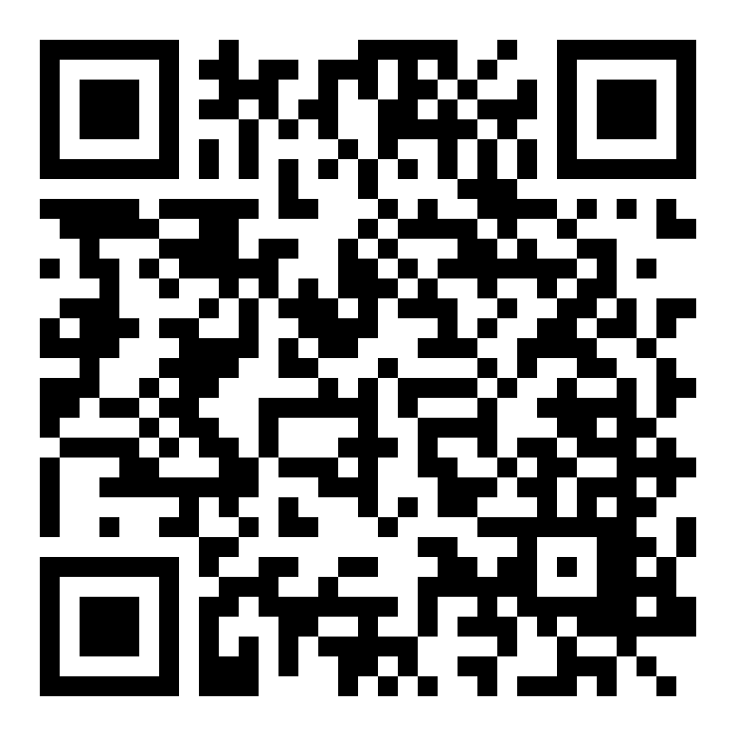
Words in the News- Title: _Flying Food
http://www.bbc.co.uk/learningenglish/english/features/witn/ep-150211
Word or PHRASE:  - restaurateurs  - drones  - diners  - charted  - the human touch | DEFINITION:
Transcript  Is it a bird? Is it a plane? No, it's a flying waiter.  Due to a lack of staff, restaurateurs in Singapore have started to use drones to get food from the kitchens to the diners.  The robots fly over the heads of customers on paths charted by a computer.  But are these foodies ready for service without the human touch? | DRAW a PICTURE:

