VOCABULARY Study Sheet CHAPTER: _1_
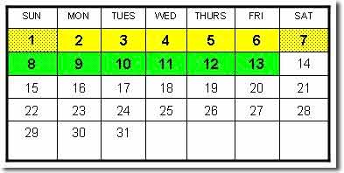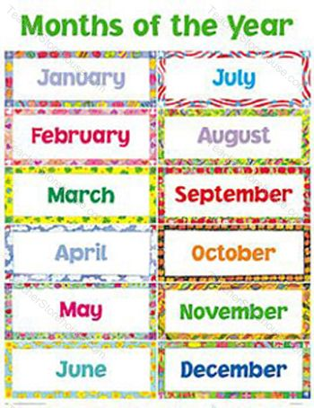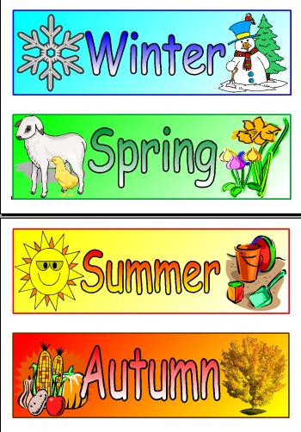
Days of the Week
- Sunday 2. Monday 3. Tuesday 4. Wednesday
___________________ ____________________ ___________________ _________________
5. Thursday 6. Friday 7. Saturday
___________________ ____________________ ______________________

Months of the Year
8. January 9. February 10. March 11. April
___________________ ____________________ ___________________ _________________
12. May 13. June 14. July 15. August 16. September
____________ ________________ _____________ ________________ ________________
17. October 18. November 19. December
______________ _________________ ________________
Seasons
20. Spring 21. Summer 22. Fall/Autumn 23. Winter
_______________ ________________ _______________________ _________________

PRACTICE spelling each vocabulary word
Sunday 2. Monday 3. Tuesday 4. Wednesday
____________________ ________________ _____________________ _____________________
____________________ ________________ _____________________ _____________________ ____________________ ________________ _____________________ _____________________
____________________ ________________ _____________________ _____________________ ____________________ ________________ _____________________ _____________________
5. Thursday 6. Friday 7. Saturday
___________________ ________________________ _______________________
___________________ ________________________ _______________________
___________________ ________________________ _______________________
___________________ ________________________ _______________________
___________________ ________________________ _______________________
8. January 9. February 10. March 11. April
____________________ ____________________ __________________ _____________________
____________________ ____________________ __________________ _____________________
____________________ ____________________ __________________ _____________________
____________________ ____________________ __________________ _____________________
____________________ ____________________ __________________ _____________________
12. May 13. June 14. July 15. August 16. September
____________ ________________ _____________ ________________ ________________
____________ ________________ _____________ ________________ ________________
____________ ________________ _____________ ________________ ________________
____________ ________________ _____________ ________________ ________________
____________ ________________ _____________ ________________ ________________
PRACTICE spelling each vocabulary word

17. October 18. November 19. December
______________ _________________ ________________
______________ _________________ ________________
______________ _________________ ________________
______________ _________________ ________________
______________ _________________ ________________
20. Spring 21. Summer 22. Fall/Autumn 23. Winter
_______________ ________________ _______________________ _________________
_______________ ________________ _______________________ _________________
_______________ ________________ _______________________ _________________
_______________ ________________ _______________________ _________________
_______________ ________________ _______________________ _________________
