VOCABULARY Study Sheet
CHAPTER: _2_
- 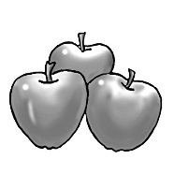 2. 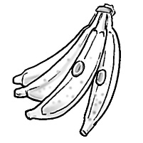 3. 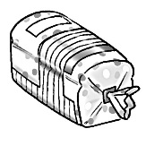 4. 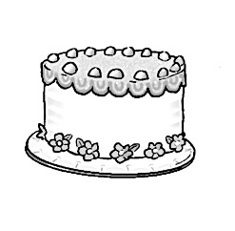5. 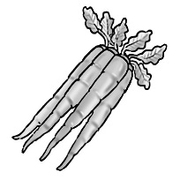
______________ ______________ ______________ _____________ ____________
6. 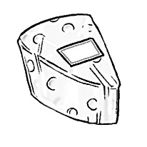 7. 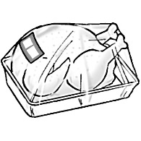 8. 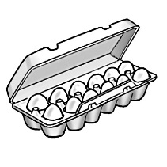 9. 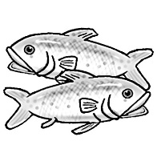10. 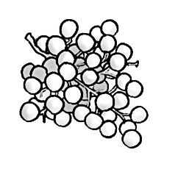
______________ ______________ ______________ ___________ ____________
11. 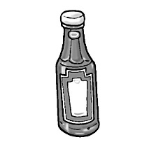 12. 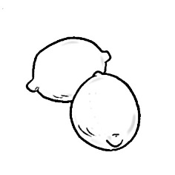 13. 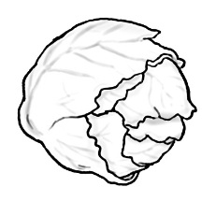14. 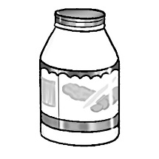 115. 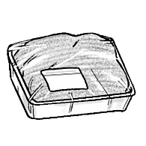________________ _________________ ______________ _______________ ____________
16. 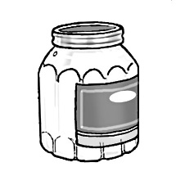 17. 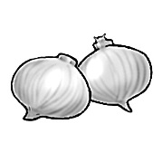 18. 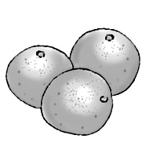 19. 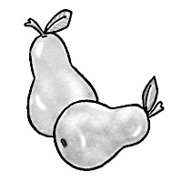 20. 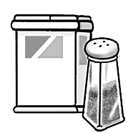
______________ ______________ ______________ ___________ ____________
21. 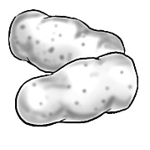 22. 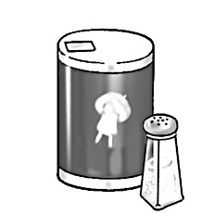 23. 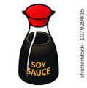 24. 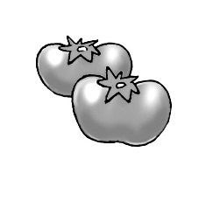
__________________ ______________ ____________________ __________________

PRACTICE spelling each vocabulary word
1. apples 2. bananas 3. bread 4. cake 5. carrots 6. cheese
___________ ____________ ____________ _________ ____________ ___________
___________ ____________ _____________ _________ ____________ ___________
___________ ____________ _____________ _________ ____________ ___________
___________ ____________ _____________ __________ ____________ ___________
___________ ____________ _____________ __________ ____________ ___________
7. chicken 8. eggs 9. fish 10.grapes 11. ketchup 12. lemons
___________ ____________ ___________ _____________ ____________ ____________
___________ ____________ ___________ _____________ ____________ ____________
___________ ____________ ___________ _____________ ____________ ____________
___________ ____________ ___________ _____________ ____________ ____________
___________ ____________ ___________ _____________ ____________ ___________
13. lettuce 14. mayonnaise 15. meat 16.mustard 17. onions 18. oranges
___________ _________________ ___________ ___________ ____________ _________
___________ _________________ ____________ ___________ ____________ _________
___________ _________________ ____________ ___________ ____________ _________
___________ _________________ ____________ ____________ ____________ _________
___________ _________________ ____________ ___________ ____________ _________
19. pears 20.pepper 21. potatoes 22. salt 23. soy sauce 24. tomatoes
___________ ____________ ____________ _______ _______________ ________________
___________ ____________ _____________ _______ _______________ ________________
___________ ____________ _____________ _______ _______________ ________________
___________ ____________ _____________ ________ _______________ ________________

